**Room Management**

**Build Status:**

* Some Bugs related to Front End
* Almost Completed
* Full Updating is under Process
* We will build QR-code for our Software
* Photos are Limited
* Content on page is also Limited but It can be Increased
* User History is remaining

**Tech/Framework used:**

* Python
* Django
* JavaScript
* HTML
* CSS
* Bootstrap

**Step to setup Django Platform:**

* **First step:** Install Django on Desktop

(env) $ python -m pip install django

* **Second step:** Create Virtual Environment

$ python3 -m venv env

$ source env/bin/activate

* **Third step:** Copy the project in Folder
* **Fourth step:** Create admin

**How to create superuser in Django?**

For creating superuser, first reach the same directory as that of**manage.py** and run the following command:

python manage.py createsuperuser

Then enter the Username of your choice and press enter.

Username: srishti

Then enter the Email address and press enter.(It can be left blank)

Email address: example@gmail.com

Next, enter the Password in-front of the Password field and press enter.Enter a strong password so as to keep it secure.

Password: ******

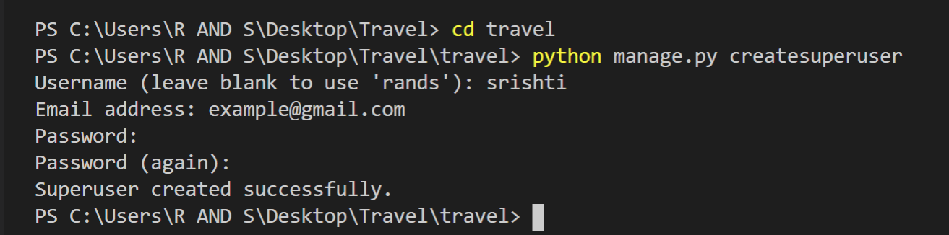

* **Fifth step:** Setting up admin email in project to receive email updates

Go to Base folder in Project file in Views.py file Change admin email

those who want to be admin

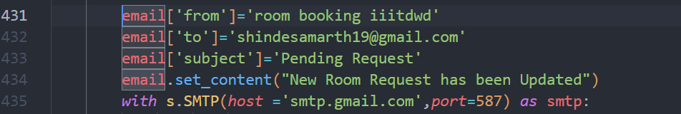

Change email in line no 432 with the email of our admin

* **Last step:** Start Your Project by typing command

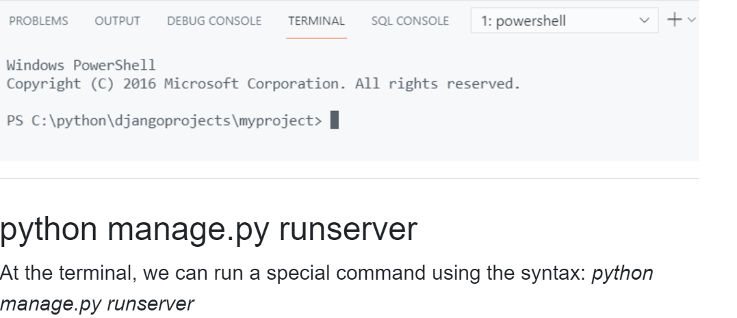

Screenshot of How project Work and it’s Functionality

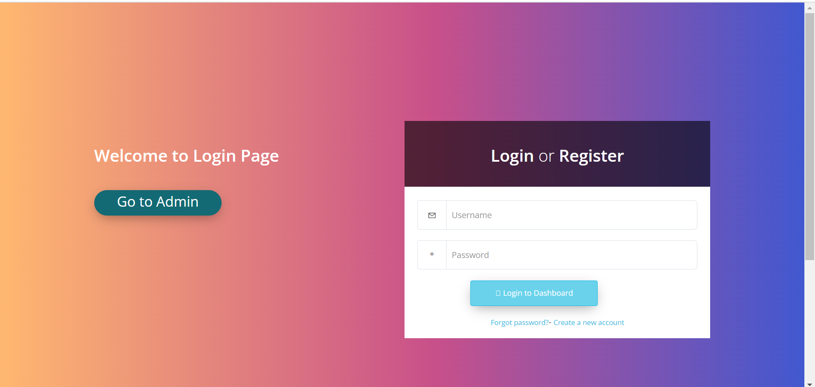

**Login page:** Here we can Login or Register(for new User)

**Extended Functionality**->Forget password, Go to admin Login

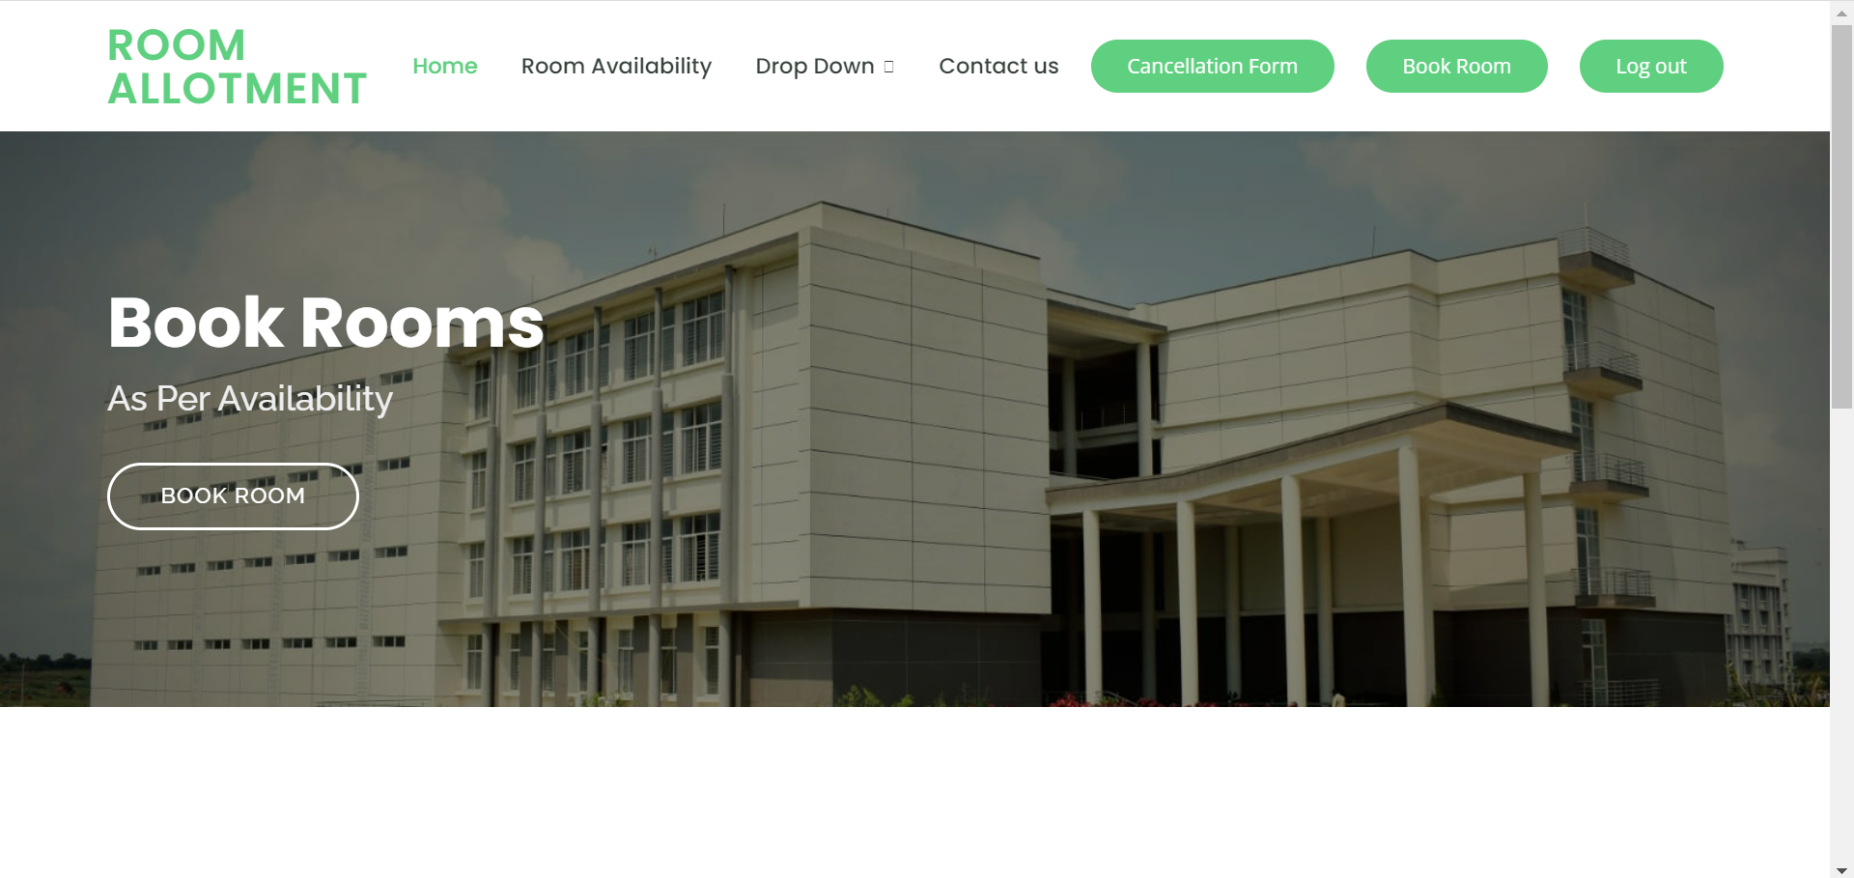

**Home Page:** Here first there is navigation bar with some options related to room booking

**Extended Functionality->** Cancellation form for cancel the room

**How to book room?**

*Here are some steps to be followed in order to avail the Room.*

* First go to Room Availability option to check the list of available rooms.
* Then select the room after looking at the image and video of that room from DROP-DOWN option.
* Then click on Book Room option and fill the registered username and email id with all necessary details and click send request option.
* After following the above mention step your request for room booking has been sent to admin. Now you will get an email update based on admins response.

Thanks for your Interest.

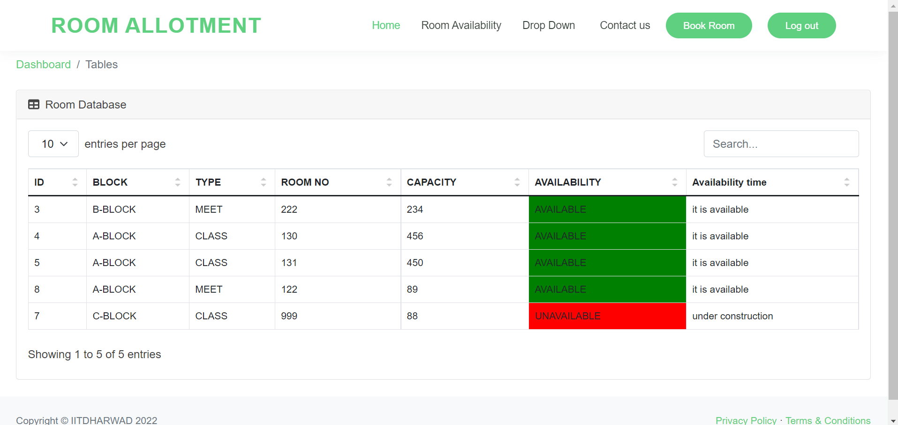

This page shows which room is available and which is unavailable and when it will be available

**Image section for our Website**

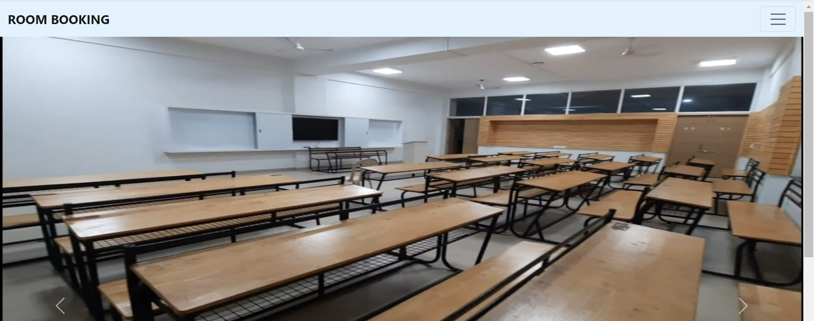

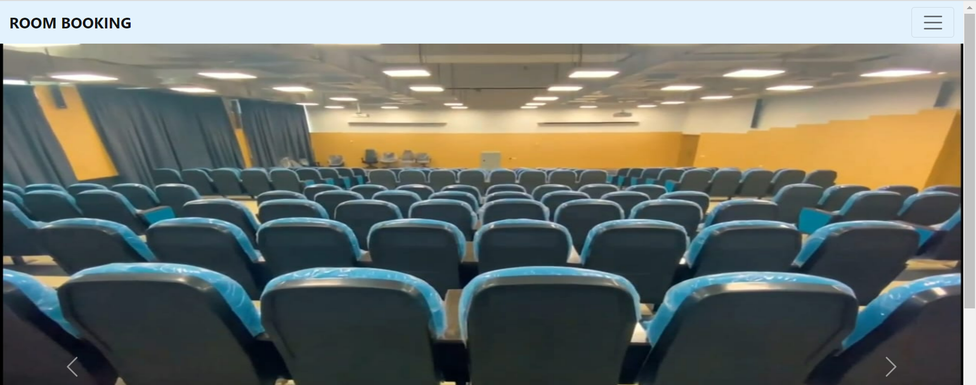

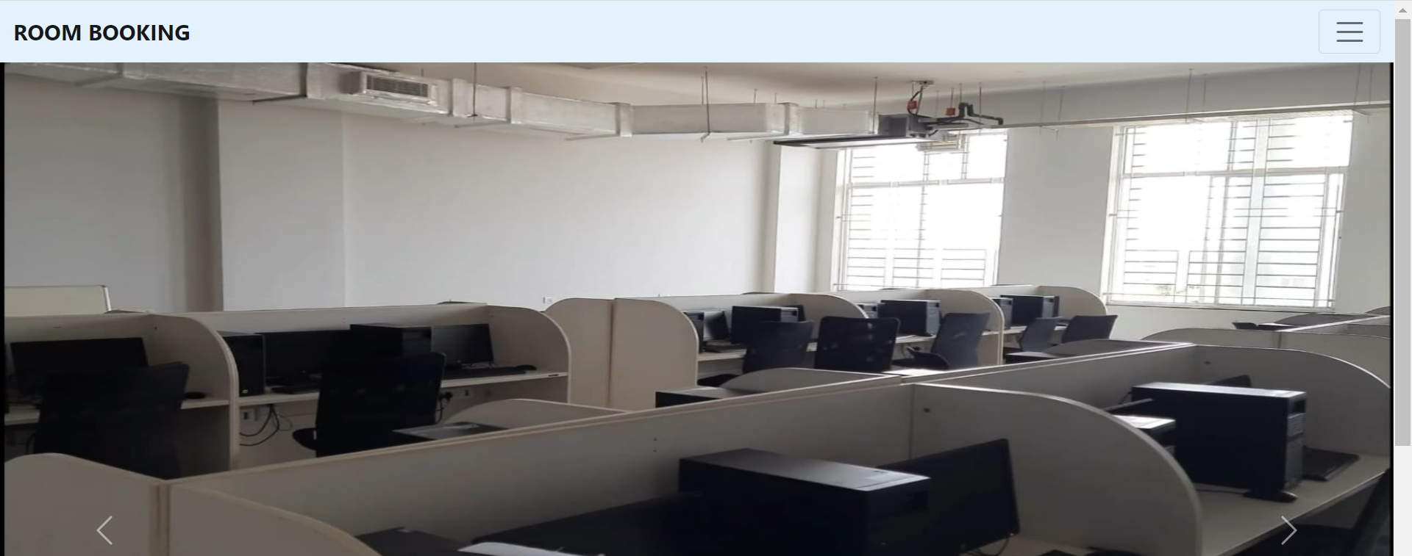

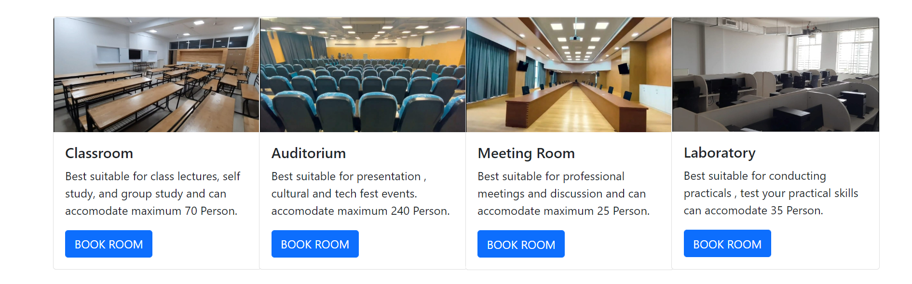

This page show image of each type of room and some information about that room

From clicking the **BOOK ROOM** Button, we will head to **Book form**

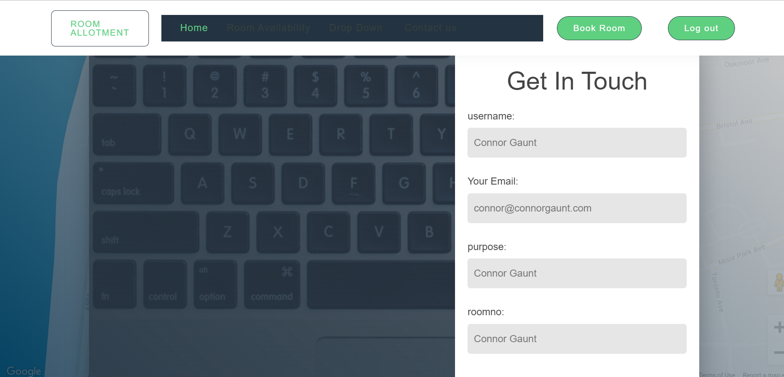

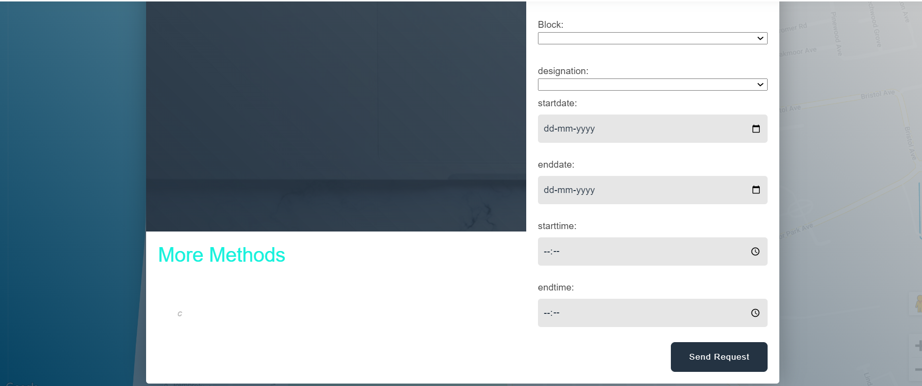

This is the form we have to fill to send request of room booking to admin

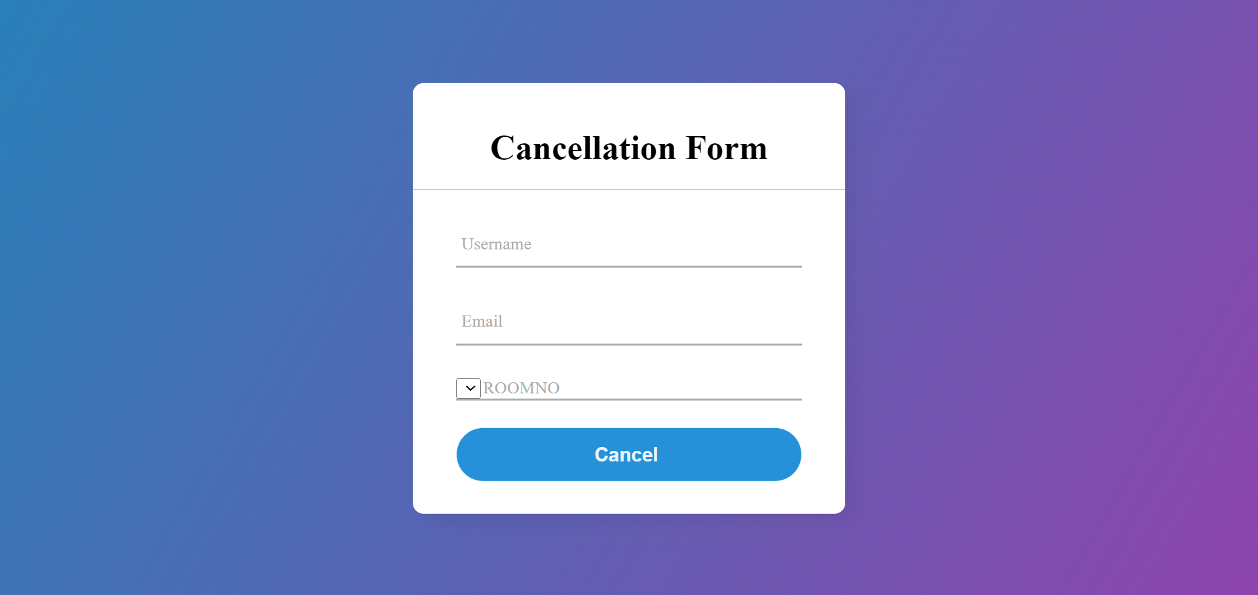



After clicking Go to Admin

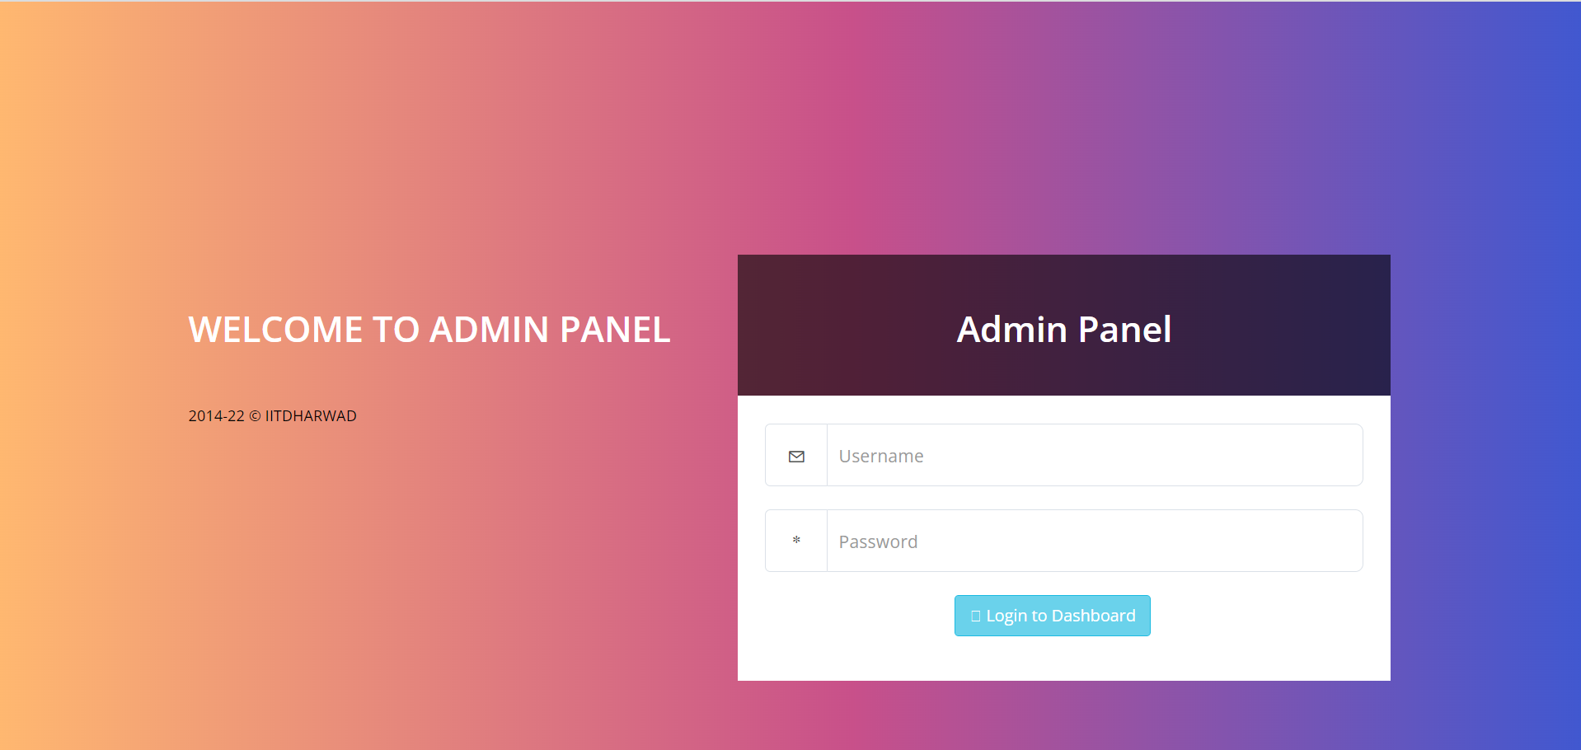

This the admin page where admin can login to his account

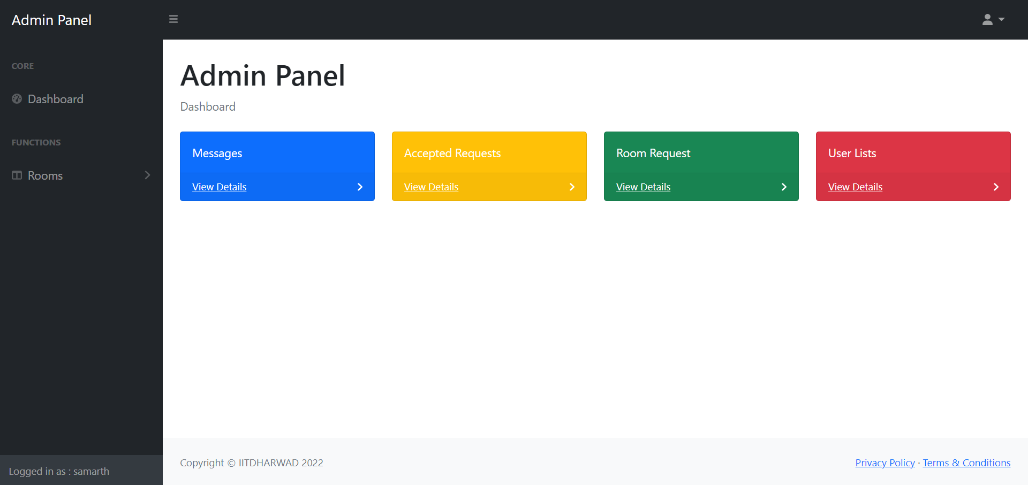

**Message:** Clicking on this we can see the message send by users to admin and answer their queries

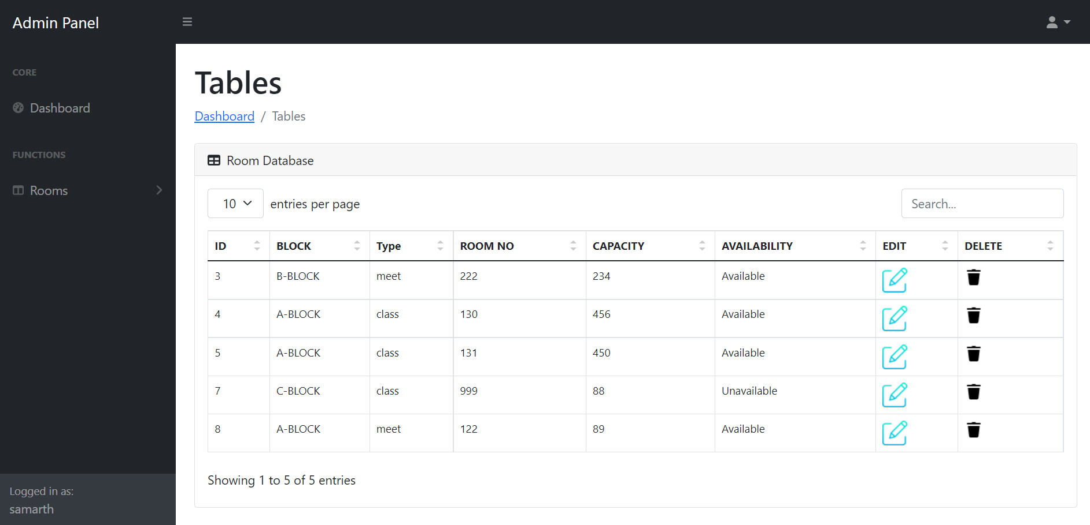

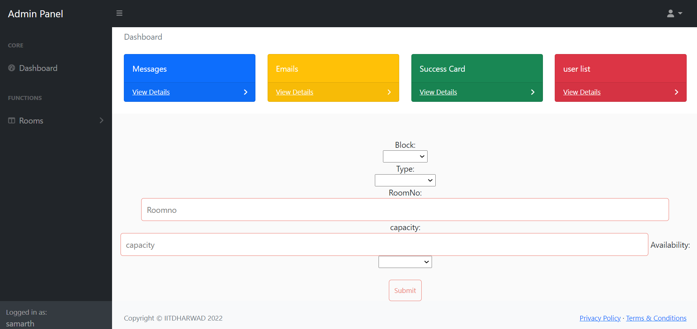

Here we can Enter Room Information in out Database

**Accepted Requests:** Clicking on this we can see accepted request

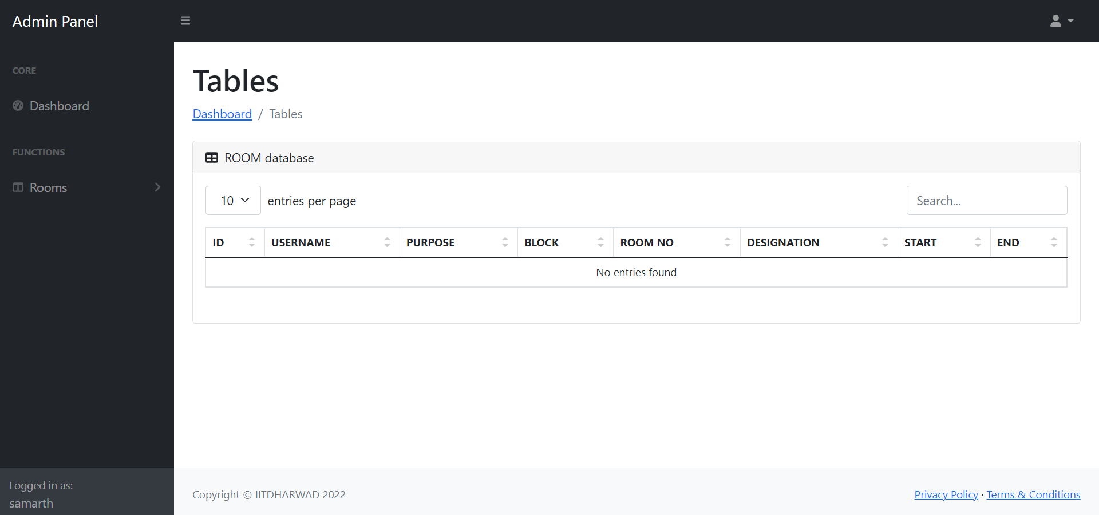

Will show the accepted user list

**Room Requests:** Clicking on this we can see room pending request



Will show the request user list

**User List:** Clicking on this we can see our User and have control on their account

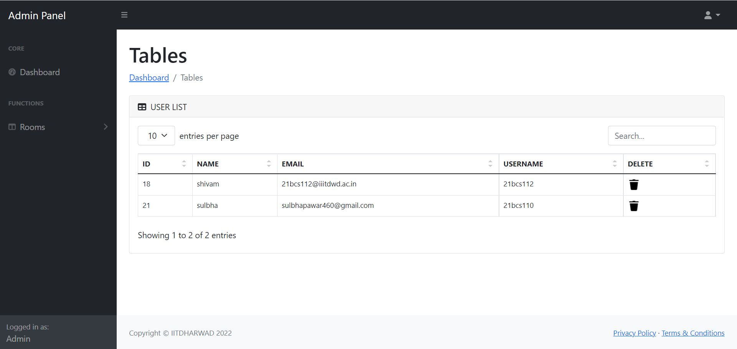

Here we can see the user of our software